**BANGLADESH UNIVERSITY OF BUSINESS AND TECHNOLOGY**

**(BUBT)**



**Lab Report**

Course Code : CSE 324

Course Title : Compiler Design Lab

Date of Submission : March 10, 2024

Submitted By

Name : Aktaruzzaman

ID : 21222203031

Intake : 41

Section : 1

Submitted To

**Ms. Adeeba Anis**

Lecturer

Department of Computer Science & Engineering

Bangladesh University of Business and Technology (BUBT)

**Experiment No: 0**6

**Experiment Name:** Finding First of any Grammer.

**Problem Structure**

The task is to design and implement a C/C++ program to find the First set of any grammar. The First set of a non-terminal in a grammar contains all terminals that can appear as the first symbol of any string derived from that non-terminal.

**Procedure**

* Define the grammar by specifying the productions for each non-terminal.
* Implement a function to compute the First set for each non-terminal recursively.
* Traverse each production of a non-terminal:
  + If the first symbol is a terminal, add it to the First set.
  + If the first symbol is a non-terminal:
    - Recursively compute the First set for that non-terminal.
    - Add the First set of that non-terminal to the First set of the current non-terminal.
    - If the non-terminal is nullable, continue to the next symbol in the production.
    - If the non-terminal is not nullable, stop and proceed to the next production.
* Repeat step 3 for all productions of each non-terminal.
* Output the First set for each non-terminal.

**Code:**

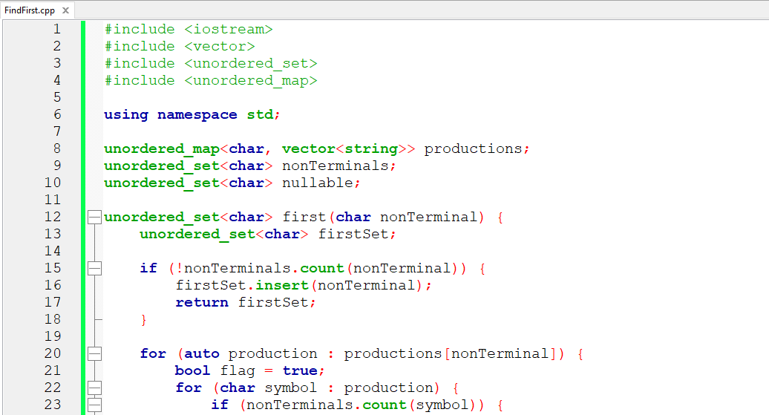

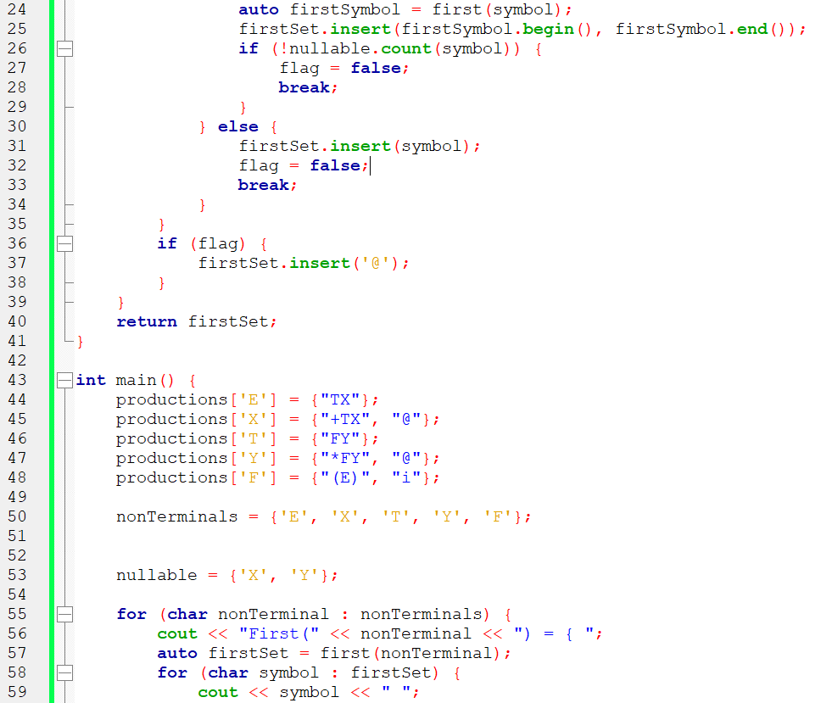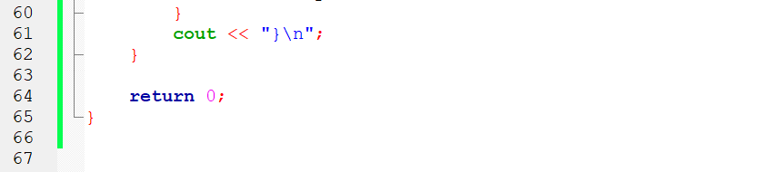

**Output**

